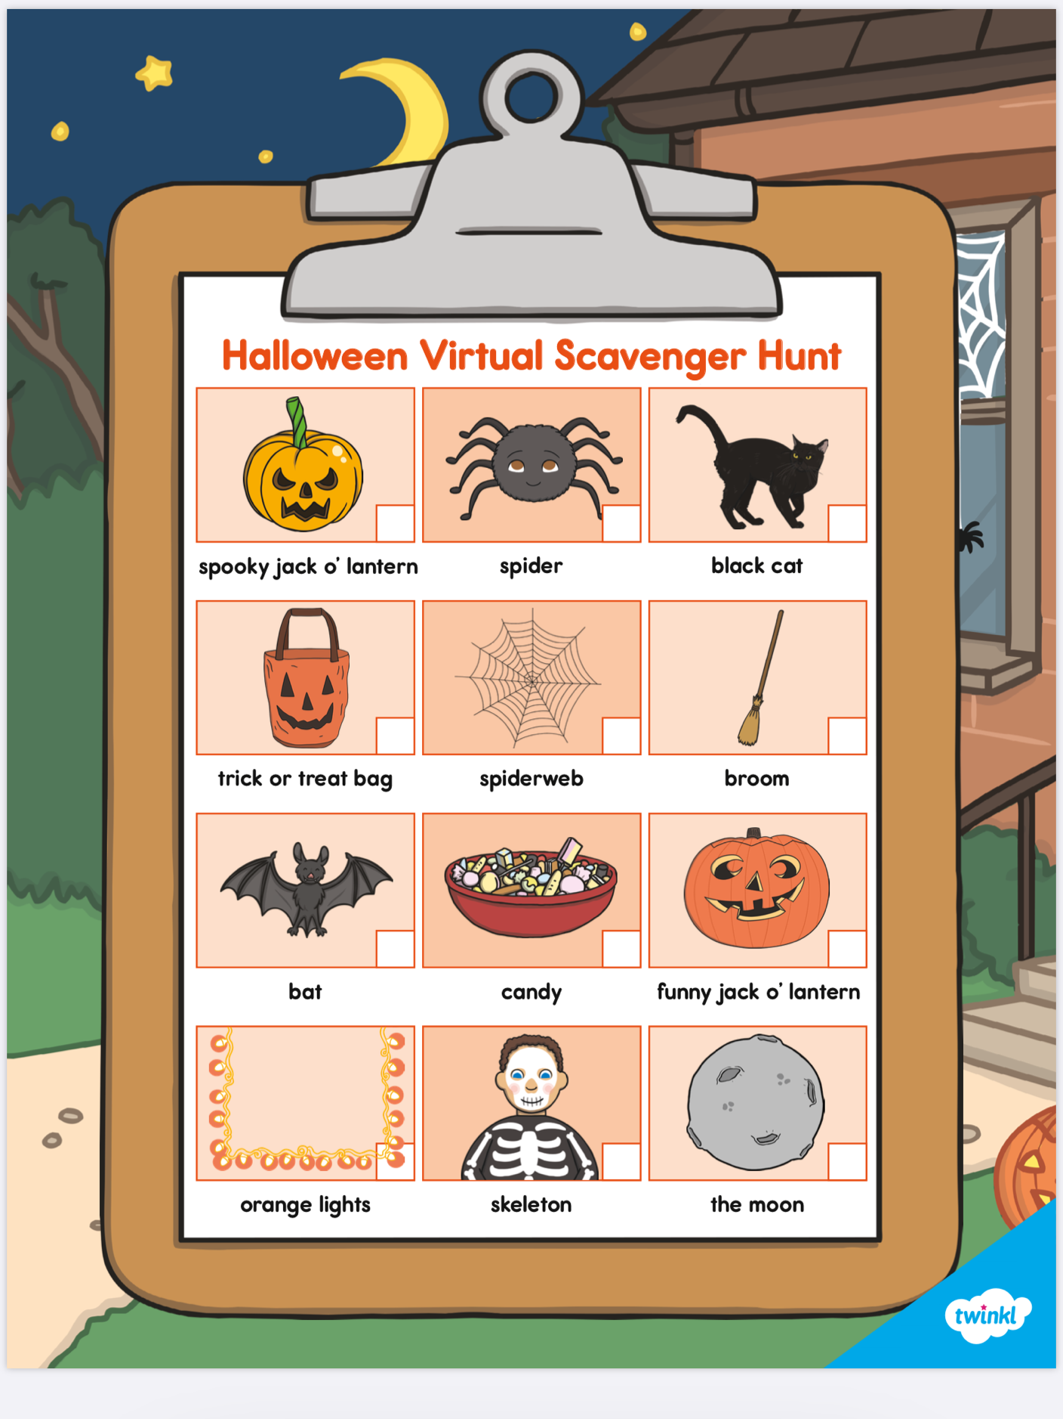**Halloween walk (Trick or Treating alternative ):** Go on a Halloween walk as a family on Halloween night (rather then trick or treating) and give each child a list of things to find on their walk (decorations etc) for every time they find each item give them a treat from your own pre-chosen treats. Eat the treats at home while watching a Halloween movie 🎃 some examples for scavenger walks to follow.

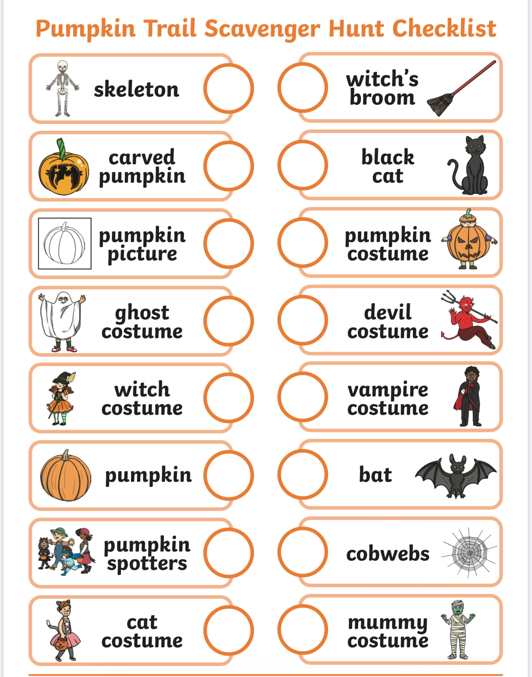

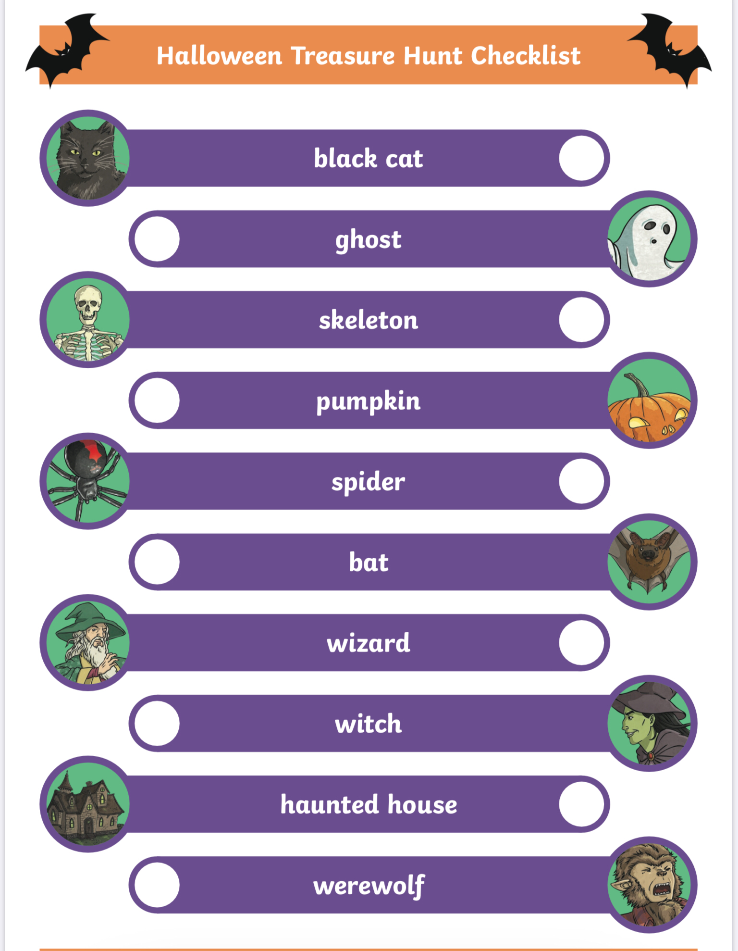

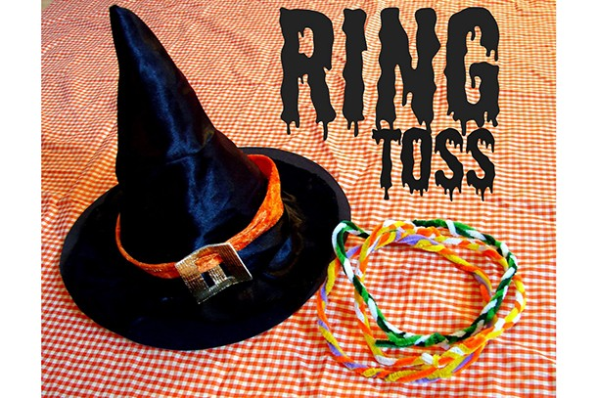**Witch Ring Toss**

You will need:

* Witch’s hat
* Pipe cleaners

Simply buy or make a simple witch’s hat,  bend pipe cleaners together to make into rings and take it in turns to try and get the rings over the hat. Ta-dah!

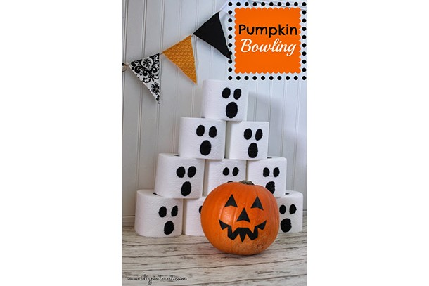**Pumpkin bowling**

You will need:

* Toilet rolls
* Black card
* Glue
* A pumpkin (or a football)

Another simple bowling game, this time using a decorated pumpkin and loo rolls! Stack the toilet rolls up, aim the pumpkin and see how many you can knock down.

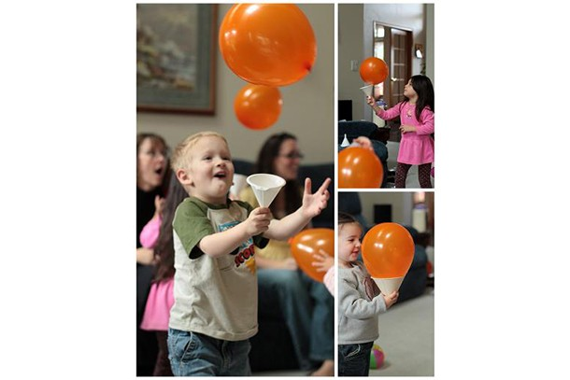**Halloween Balloon Catch**

You will need:

* Orange balloons
* Funnels

A simple but fun game which will get the kids running around after balloons. Buy ready-made funnels (you could use cone party hats if you have any lying around) or make your own and blow up a balloon for each child.

**Pin the BOO! on the Ghost**

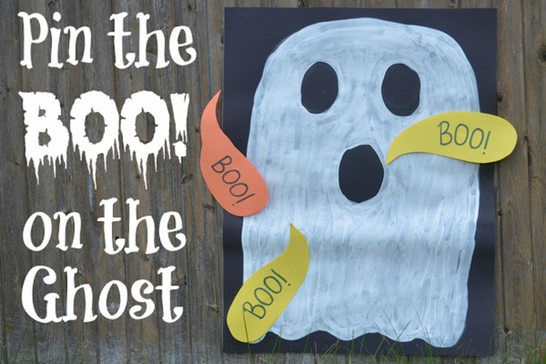

You will need:

* Black card
* Orange card
* Yellow card
* White paint
* Tape
* Blindfold

This is a spooky version of Pin The Tail On The Donkey. Get your kids to help you make a ghost, and neatly cut out “boo” speech bubbles.

The aim is to get the speech bubble as close to the mouth as possible – with a blindfold on.

[**Mummy wrap**](http://modernmomentsdesigns.com/2011/10/06/school-halloween-party-snacks-and-activities/)**:**

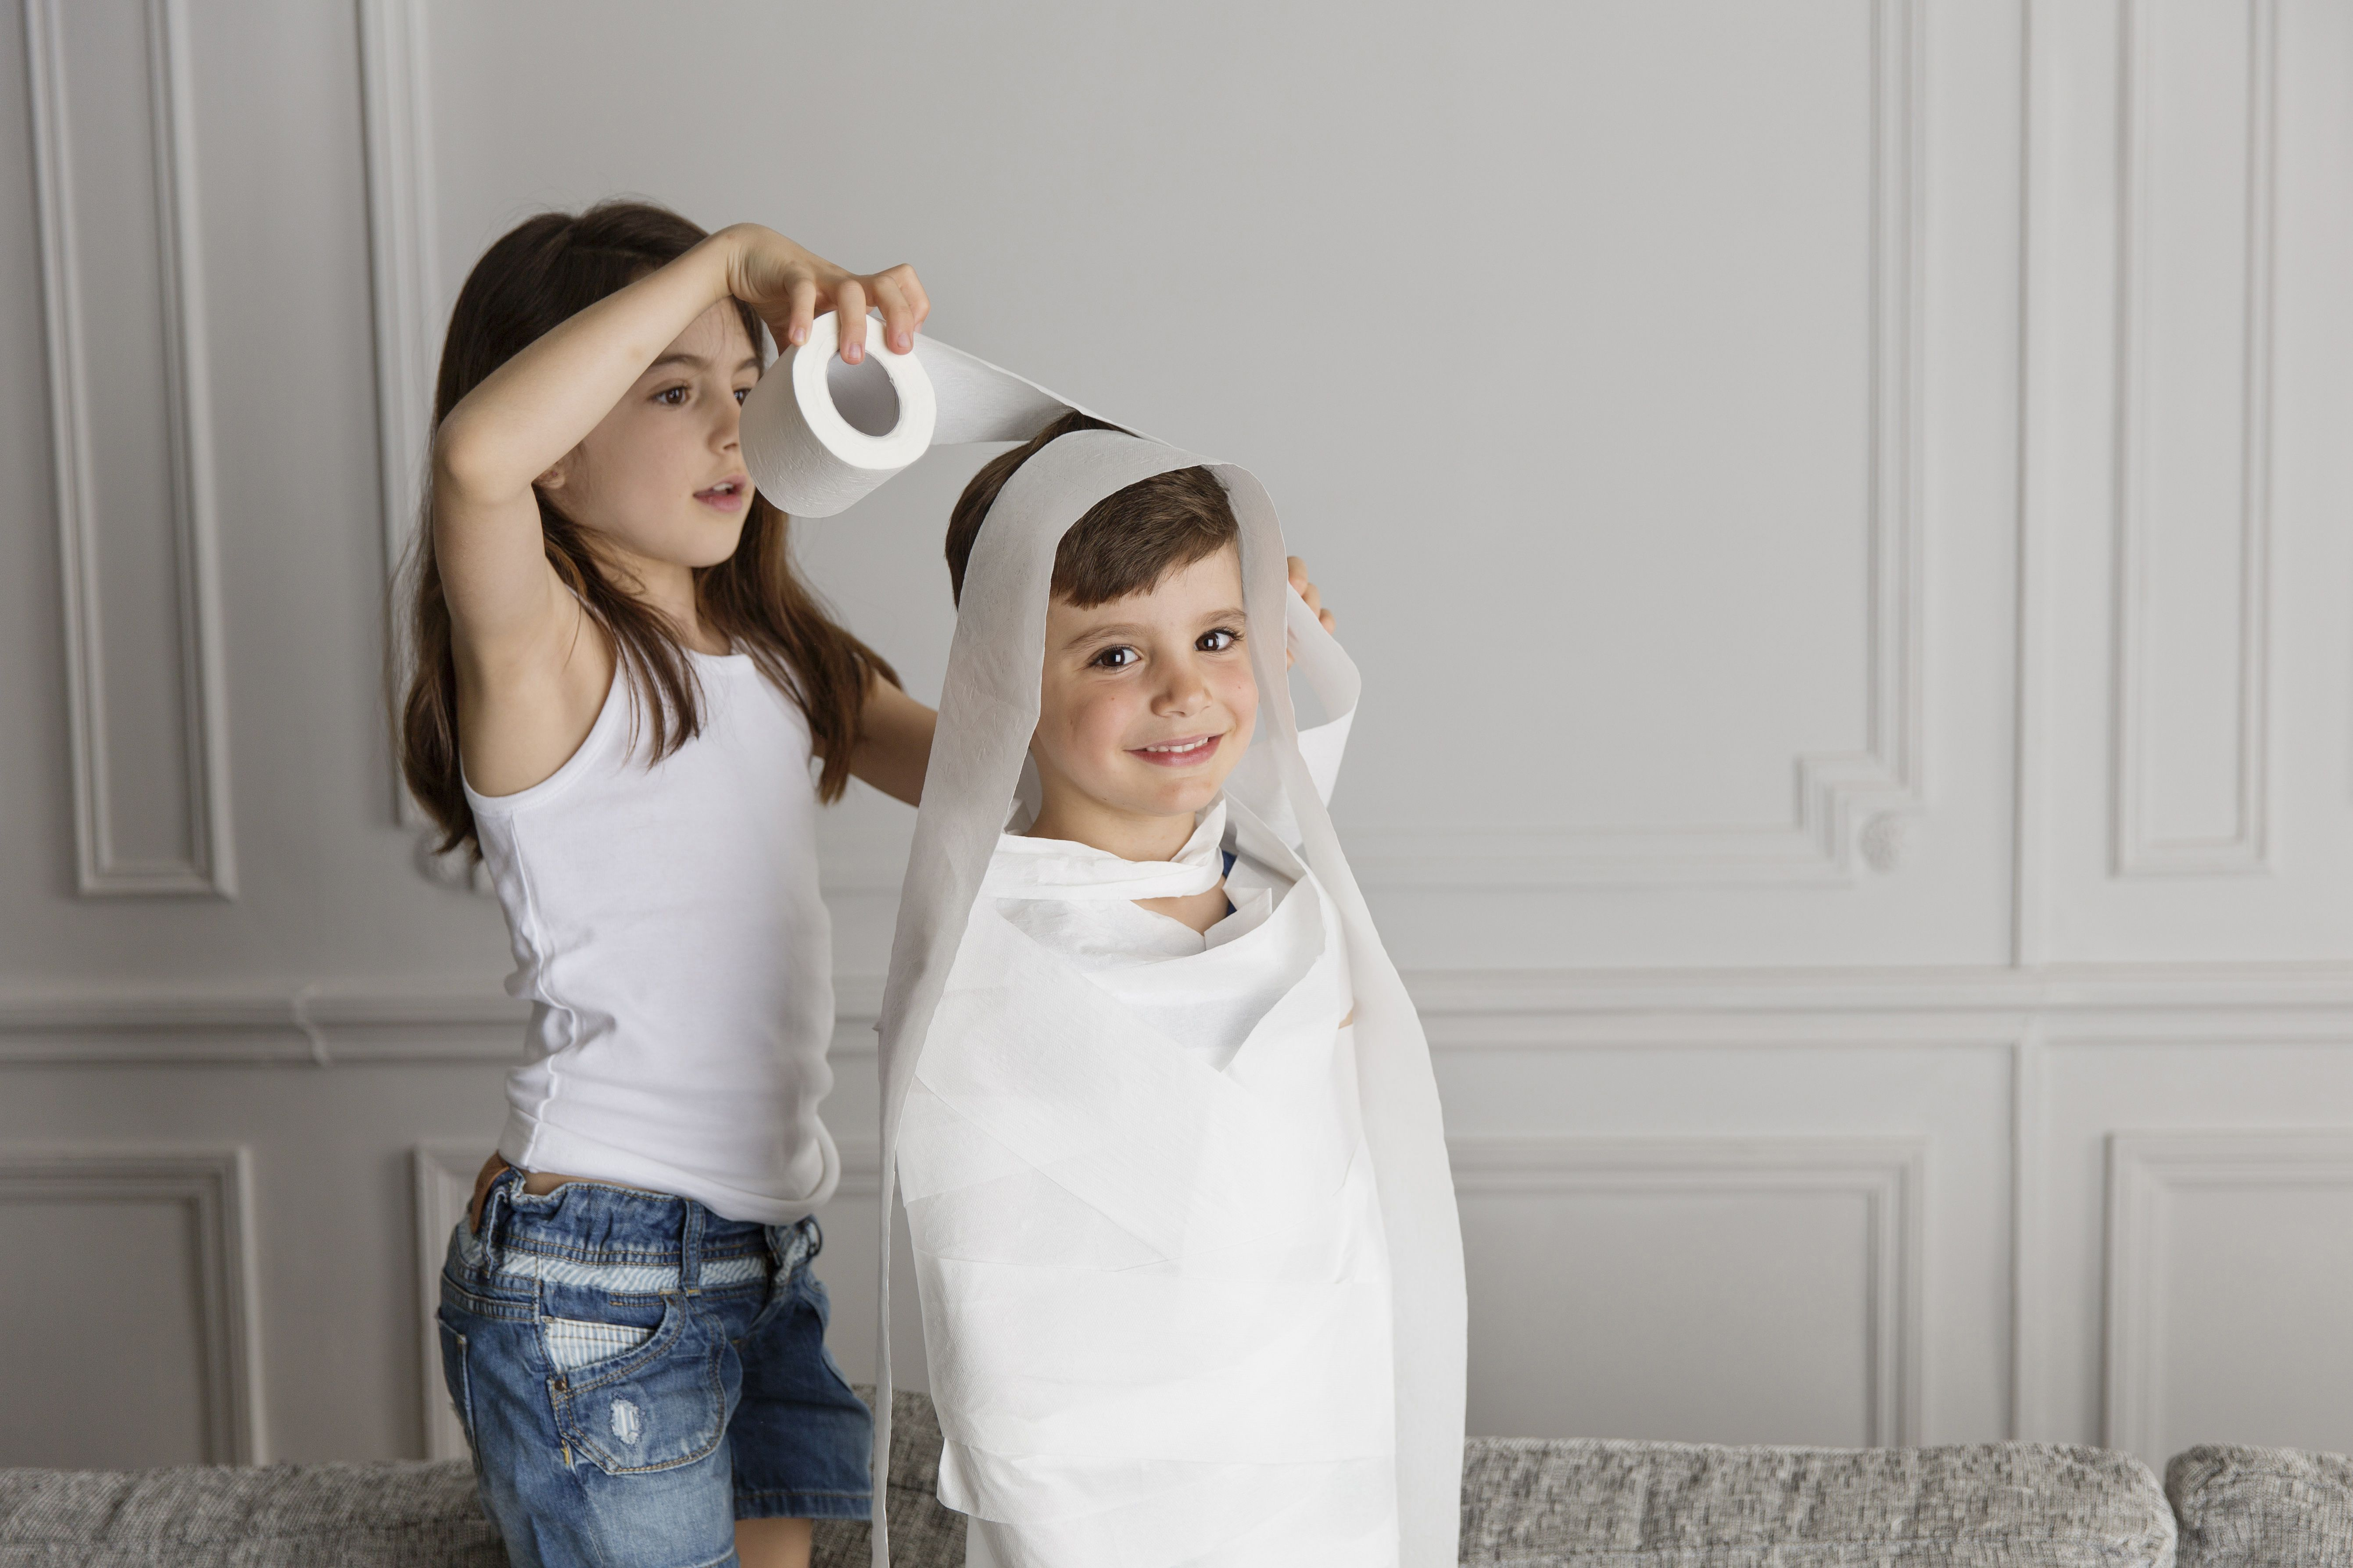 Divide guests into teams and have each one choose the person to be "mummified." Hand each team a roll of toilet paper. The first one to wrap their mummy wins!

[**Monster Freeze Dance**](http://www.kidspot.com.au/things-to-do/activities/monster-mash-freeze-dance):

Put on some Halloween tunes and have the kids boogie until the music stops when they have to freeze. Children are eliminated for not freezing and the last monster standing is the winner.

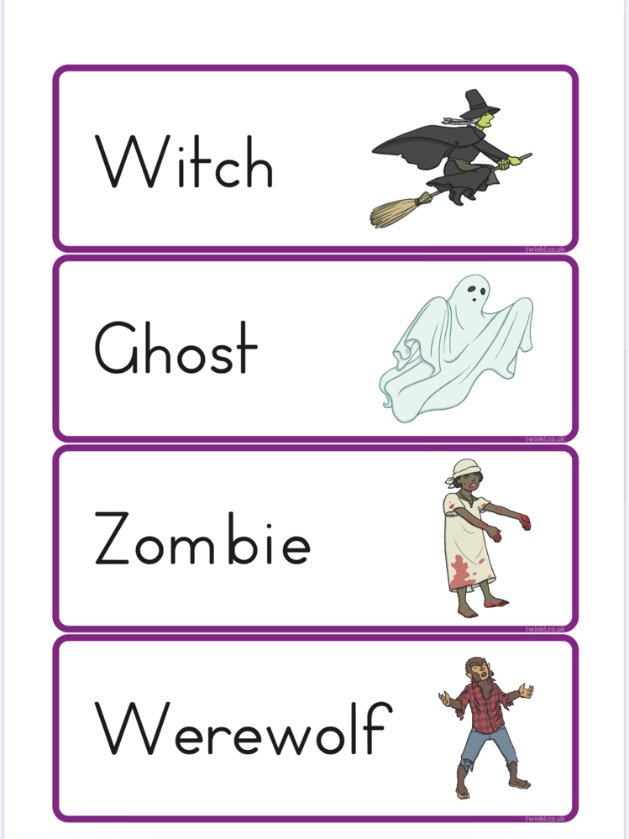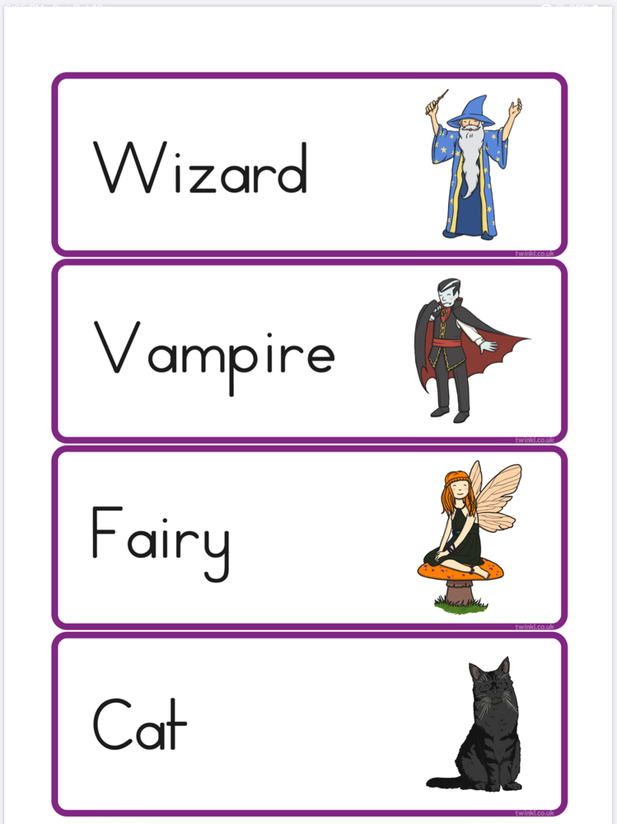**Who am I? (Guess the costume)** You'll need to tape a character name on the children's backs and give them clues to help them figure out who the character is. There are lots of ideas for Halloween characters here.