Date | Week 1: 1st – 5th March
English | Exercise your English: Read ‘The Climb’ p58/59 EYE and answer questions in Sections A, B and C on p59  - Grammar: Adverbs – EYE pg 61  - Spellings – can be found on Google classroom  - Cursive Handwriting: two pages per week.  - Poem: ‘I Purchased a Virtual Puppy’  - Read at home: two per week  - Accelerated reading: 25 minutes per day; using class novels or articles online on AR website.  - Reading eggs tasks.
Gaeilge | An Teilifís
Maths | - Translate addition, subtraction, multiplication or division number sentences with a frame into word problems in Planet Maths: p176, 177, 178, 179 and 180  - Mathletics tasks  - Revise timetables
S.E.S.E. | History: Déirdre of the Sorrows  - Read story of Déirdre of the Sorrows on powerpoint  - Place the events of her life on a timeline  - Complete ‘True or False’ activity on her story  - Unscramble the words and rewrite the correct sentence  - Re-tell story through pictures – comic strip  - Complete Wordsearch about her story
S.P.H.E. | Mindful Matters Page of your choice
Art | Learning Activities/ methodologies (Objectives):  - Paper weaving.  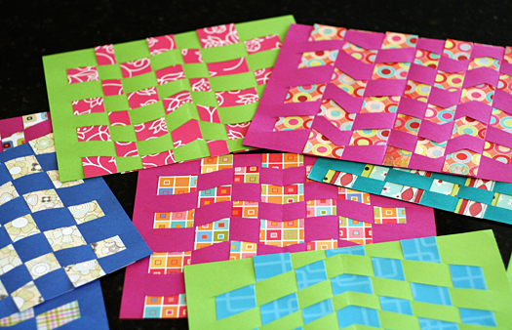  - Make bookmarks / placemats using weaving paper strips.  Placemat: https://www.youtube.com/watch?v=9_es5tryDaY  Bookmark: https://www.youtube.com/watch?v=Jpbv2LdleqU
P.E.  Keep yourself active and do 30 minutes of exercise each day ☺ | YouTube channels to follow;  The Body Coach for kids  Cosmic Yoga for kids  Go Noodle  Just dance

